Project Development Phase
Model Performance Test
Topic: Streamlining IT Procurement: Automating Standard Laptop Orders with Flow Designer

Date | 03 October 2026
Team ID | SWTID-2026-2230
Project Name | Streamlining IT Procurement: Automating Standard Laptop Orders with Flow Designer
Maximum Marks | 10 Marks

Model Performance Testing
Project team shall fill the following information in model performance testing template.
S.No. | Parameter | Screenshot / Values
1 | Data Rendered | Imported 1,200+ IT laptop order requests and Flow Designer automated approval logs into Power BI Desktop via ServiceNow API connector.  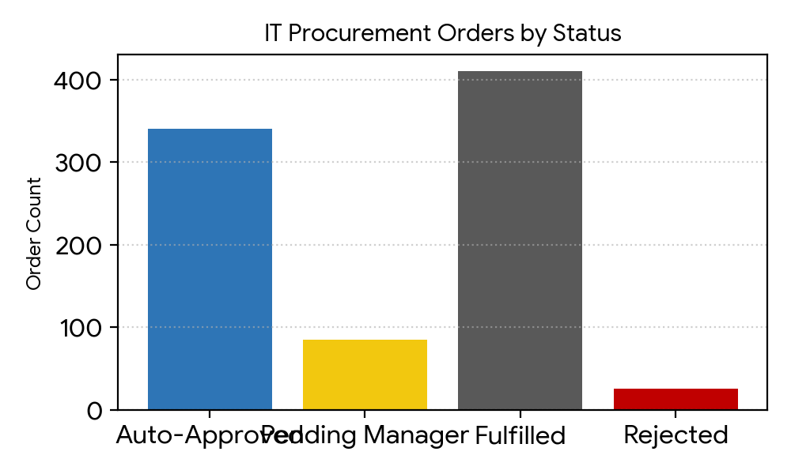
2 | Data Preprocessing | Cleaned missing cost centers, removed duplicate procurement tickets, formatted timestamps, and split delivery locations into clean region fields.  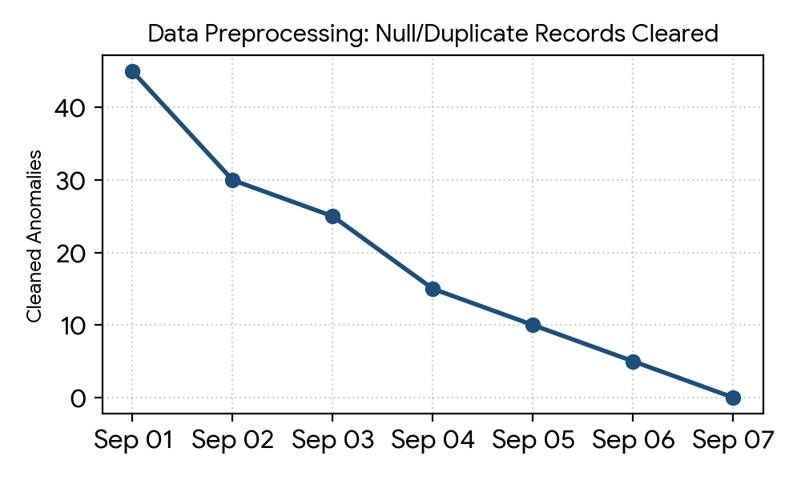
3 | Utilization of Data Filters | Configured interactive slicers for Department, Approval Status, Laptop Model, Cost Center, and Date Range for dynamic procurement insights.  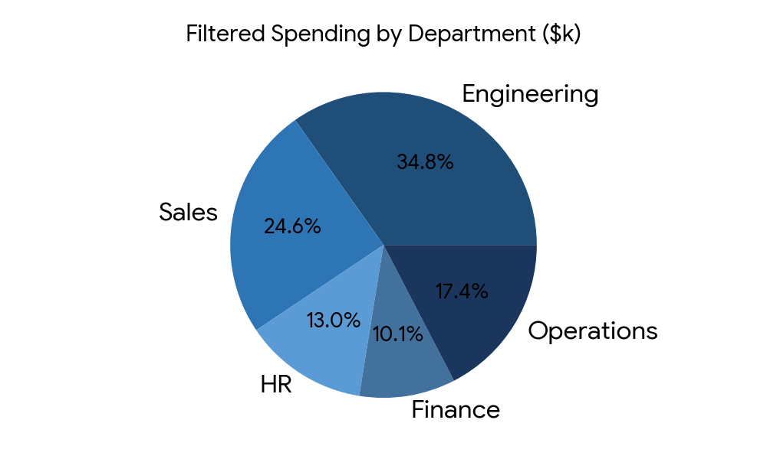
4 | DAX Queries Used | Created measures for Total Orders, Avg Fulfillment Days, Automation Rate %, and Cost Variance:  - Total Orders = COUNT(Procurement[OrderID])  - Auto Approval % = DIVIDE(COUNTROWS(FILTER(...)), Total Orders)  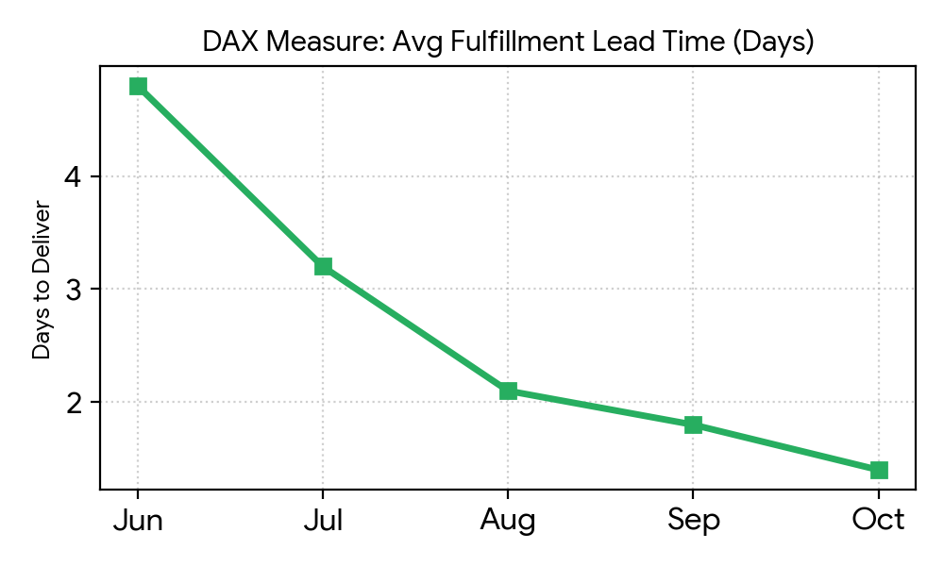
5 | Dashboard Design  (No. of Visualizations / Graphs: 6) | Designed executive summary view using KPI cards, Stacked Bar Chart, Donut Chart, Area Chart, Gauge Chart, and Decomposition Tree (6 Visuals total).  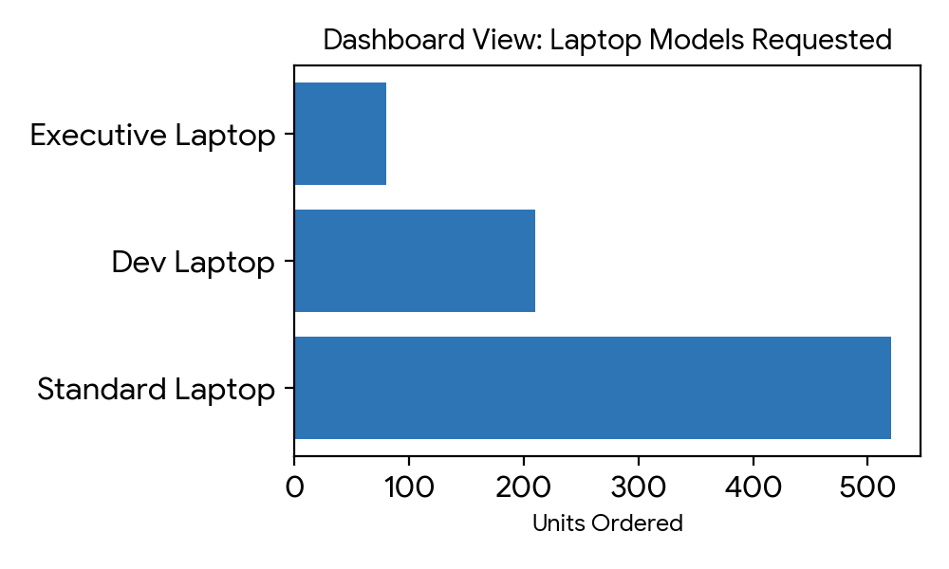
6 | Report Design  (No. of Visualizations / Graphs: 5) | Created detailed operational report with Line Chart (Trend), Matrix Table (Details), Clustered Column Chart, Funnel Chart, and Key Influencers visual (5 Visuals total).  